MILESTONE LIST:

|  |  |
| --- | --- |
| **Project Name** | Emerging Methods For Early Detection of  Forest Fires |
| **Project Domain** | Artificial Intelligence |
| **Team Leader** | Dinesh V |
| **Team I’d** | PNTIBMSm18 |
| **Project Owner** | IBM |
| **Date** | 5 November 2022 |
| **No of Members** | 4 |

|  |  |  |  |  |
| --- | --- | --- | --- | --- |
| **Milestone Name** | **Milestone Number** | **Description** | **Mandatory** | **Optional** |
| Project Objectives | M-001 | We will be able to learn to prepare dataset, image processing, working with CNN layers, read images using Open CV and  CNN for computer vision AI | Yes | - |
| Project Flow | M-002 | A project management process flowchart is a graphical aid, designed to visualize the sequence of steps to be followed throughout the project management  process | Yes |  |
| Pre-Requisites | M-003 | To complete this project we should have known following project such as Keras , Tensor flow , Python ,Anaconda, Open CV,  Flask, Scikit-learn etc… | Yes |  |
| Prior Knowledge | M-004 | One should have knowledge on the Supervised Learning ,CNN and Regression Classification and Clustering,  ANN | Yes |  |
| Data collection | M-005 | We can collect dataset from different open sources like kaggle.com, UCI  machine learning etc | Yes |  |
| Image Preprocessing | M-006 | Importing the Image Data Generator libraries, Define Parameters/Arguments for Image Data Generator class, Applying Image Data Generator Functionality to  Train set and test set | Yes |  |
| Model Building | M-007 | Importing the model building libraries, Initializing the model, Adding CNN layers, Adding Dense layers, Configuring  the learning Process, Train the model, Save | Yes |  |

|  |  |  |  |  |
| --- | --- | --- | --- | --- |
|  |  | The model, Predictions. |  |  |
| Video Analysis | M-008 | Open cv for video processing, creating an account in twilio service and  sending alert message | Yes |  |
| Train CNN model | M-009 | Register for IBM Cloud and train Image Classification Model | Yes |  |
| Ideation Phase | M-010 | Prepare Literature Survey on the selected Project and Information Gathering,  empathy map and ideation | Yes |  |
| Project Design  Phase-I | M-011 | Prepare Proposed solution , problem-  solution fit and Solution Architecture | Yes |  |
| Project Design  Phase-II | M-012 | Prepare Customer journey ,functional requirements, Data flow diagram and  Technology Architecture | Yes |  |
| Project Planning  Phase | M-013 | Prepare Milestone list , Activity list and  Sprint Delivery Plan | Yes |  |
| Project  Development Phase | M-014 | Project Development delivery of Sprint 1,  Sprint 2, Sprint 3, Sprint 4 | Yes |  |

**ACTIVITY LIST:**

|  |  |  |  |  |
| --- | --- | --- | --- | --- |
| **Activity Number** | **Activity Name** | **Detailed Activity Description** | **Assigned To** | **Status** |
| 1.a | Access Resources | Access the resources (courses) in project dashboard | All Members | COMPLETED |
| 1.b | Rocket chat Registration | Join the mentoring channel via platform&  rocket-chat mobile app. | All Members | COMPLETED |
| 1.c | Access Workspace | Access the guided project workspace | All Members | COMPLETED |
| 1.d | IBM Cloud registration | Register on IBM Academic Initiative& Apply Feature for IBM  Code Cloud Credits. | All Members | COMPLETED |
| 1.e | Project Repository Creation | Create GitHub account &collaborate with Project Repository in  Project workspace. | All Members | COMPLETED |
| 1.f | Environment Setup | Set-up the Laptop /  Computers based on the pre-requisites for each | All Members | COMPLETED |

|  |  |  |  |  |
| --- | --- | --- | --- | --- |
|  |  | technology track |  |  |
| 2.a | Literature survey | Literature survey on the selected project&  Information Gathering | All Members | COMPLETED |
| 2.b | Technology Training | Attend the technology trainings as per the training  Calendar. | All Members | COMPLETED |
| 2.c | Empathy Map | Prepare Empathy Map Canvas to capture the user  Pains & Gains, Prepare list of problem statements | All Members | COMPLETED |
| 2.d | Technology Training | Attend the technology trainings as per  the training Calendar. | All Members | COMPLETED |
| 2.e | Brainstorming | List the ideas (at least 4 per each team member) by organizing the brainstorming session and prioritize the top 3 ideas  based on the feasibility &importance. | All Members | COMPLETED |
| 2.f | Technology Training | Attend the technology trainings as per  the training Calendar. | All Members | COMPLETED |
| 3.a | Proposed Solution Document | Prepare the proposed solution document, which includes the novelty, feasibility of idea, business model,  Social impact, scalability of solution, etc. | All Members | COMPLETED |
| 3.b | Technology Training | Prepare problem - solution fit document& Solution  Architecture. | All Members | COMPLETED |
| 3.c | Problem - Solution fit | Prepare problem - solution fit document | All Members | COMPLETED |
| 3.d | Solution Architecture | Prepare problem- Solution Architecture. | All Members | COMPLETED |
| 3.e | Technology Training | Attend the technology trainings as per  the training Calendar. | All Members | COMPLETED |
| 4.a | Customer Journey Map | Prepare the customer  journey maps to | All Members | COMPLETED |

|  |  |  |  |  |
| --- | --- | --- | --- | --- |
|  |  | understand the user interactions & experiences with the application  (entry to exit). |  |  |
| 4.b | Technology Training | Attend the technology trainings as per the training  Calendar. | All Members | COMPLETED |
| 4.c | Functional Requirements&  Data Flow Diagrams | Prepare the Functional Requirement Document & Data-Flow Diagrams. | All Members | COMPLETED |
| 4.d | Technology Architecture | Prepare Technology Architecture of the  solution. | All Members | COMPLETED |
| 4.e | Technology Training | Attend the technology  trainings as per the training Calendar. | All Members | COMPLETED |
| 5.a | Milestone& Activity List | Prepare Milestone & Activity List. | All Members | COMPLETED |
| 5.b | Sprint Delivery Plan | Prepare Sprint Delivery Plan | All Members | IN PROGRESS |
| 6 | Data Collection | Collect datasets from different open sources like kaggle.com, data.gov, UCI machine learning  repository, etc. | All Members | IN PROGRESS |
| 7.a | Image Preprocessing | Importing the Image Data Generator  Library | All Members | IN PROGRESS |
| 7.b | Image Preprocessing | Define the  Parameters / arguments for Image Data Generator class. | All Members | IN PROGRESS |
| 7.c | Image Preprocessing | Applying Image Data Generator functionality to train set and test set. | All Members | IN PROGRESS |
| 8.a | Model Building | Importing the model  building libraries | All Members | IN PROGRESS |
| 8.b | Model Building | Initializing the model | All Members | IN PROGRESS |
| 8.c | Model Building | Adding CNN Layers | All Members | IN PROGRESS |
| 8.d | Model Building | Adding Dense Layers | All Members | IN PROGRESS |
| 8.e | Model Building | Configuring the learning | All Members | IN PROGRESS |

|  |  |  |  |  |
| --- | --- | --- | --- | --- |
|  |  | process |  |  |
| 8.f | Model Building | Training the Model | All Members | IN PROGRESS |
| 8.g | Model Building | Save the model | All Members | IN PROGRESS |
| 8.h | Model Building | Predictions | All Members | IN PROGRESS |
| 9.a | Video Analysis | OpenCV for video  Processing. | All Members | IN PROGRESS |
| 9.b | Video Analysis | Creating an account in  Twilio service | All Members | IN PROGRESS |
| 9.c | Video Analysis | Sending alert message | All Members | IN PROGRESS |
| 10.a | Train CNN Model on  IBM | Register for IBM Cloud | All Members | IN PROGRESS |
| 10.b | Train CNN Model on IBM | Train Image Classification Model | All Members | IN PROGRESS |

**Milestone:**

* Modern Technology are increasing and optimizing the Performance of the Artificial Intelligences (AI) Model.
* The fire detection is important in this scenario.
* Finding of the exact location of the fire and sending notification to the fire authorities soon after the occurrence of fire can make a positive impact.
* We have implemented a fire detection system to detect fire by capturing images.
* The system uses CNN (convolution neural network), and image processing techniques.
* In this Project Milestone will be given the Best Solution for the nature of forests using the complete friendly and simple user interface web application to fetching the solution by own.
* In addition, process we are planned to add a valid Module that is Early Detection of Forest Fires. It can give both Artificial and Natural of forests.

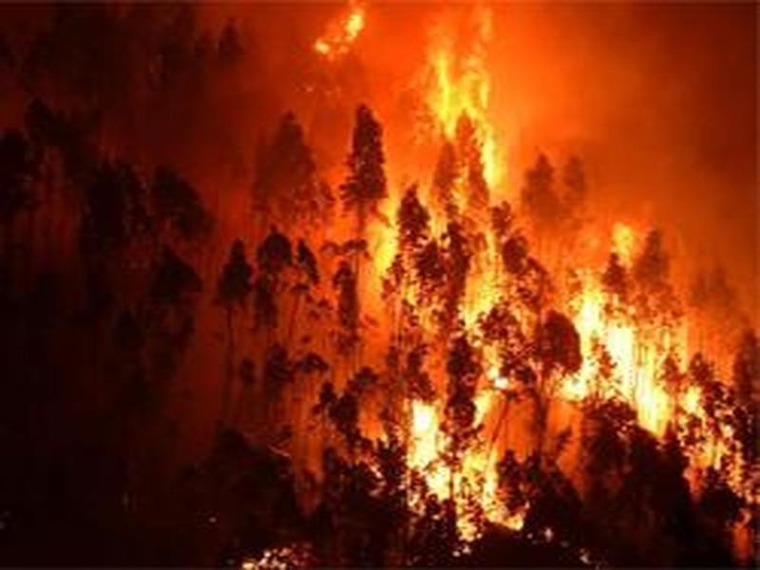

**Activity List:**

* In Project Management Planning is an Important task to scheduling the phrase of the project to the Team Member.
* In this Activity can shows the various activity are allocated and Done by the Team Members!
* In Project we can Split into the Four Step of Phrases are,
* Phrase 1: Information Collection and Requirement Analysis
* Phrase 2: Project Planning and Developing Modules
* Phrase 3: Implementing the High Accuracy Deep Learning Algorithm to Perform
* Phrase 4: Deploying the Model on Cloud and Testing the Model and UI Performance

**Agile Methodology for Activity Planning**

